Computer Graphics and Animation

Assignment Report

# URLS

## Main Project

* A VR experience where the user sits in a plane orbiting around the sun. They can fly by and view all other planets in the galaxy.
* <http://unn-w16006135.newnumyspace.co.uk/KF6018_Assignment_1/project/>

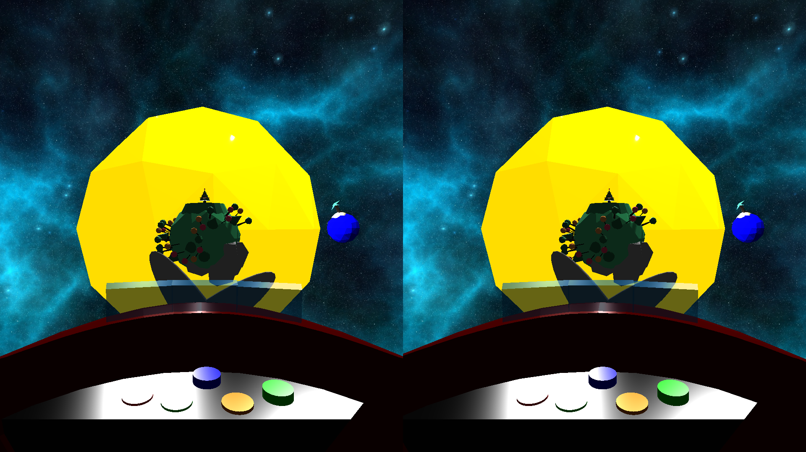

## Object Viewer

* An extra mini project to allow each object to be viewed individually. The intention of the object viewer is to allow the markers to get a good detailed look at each object used in the project.
* <http://unn-w16006135.newnumyspace.co.uk/KF6018_Assignment_1/project/object_viewer.html>

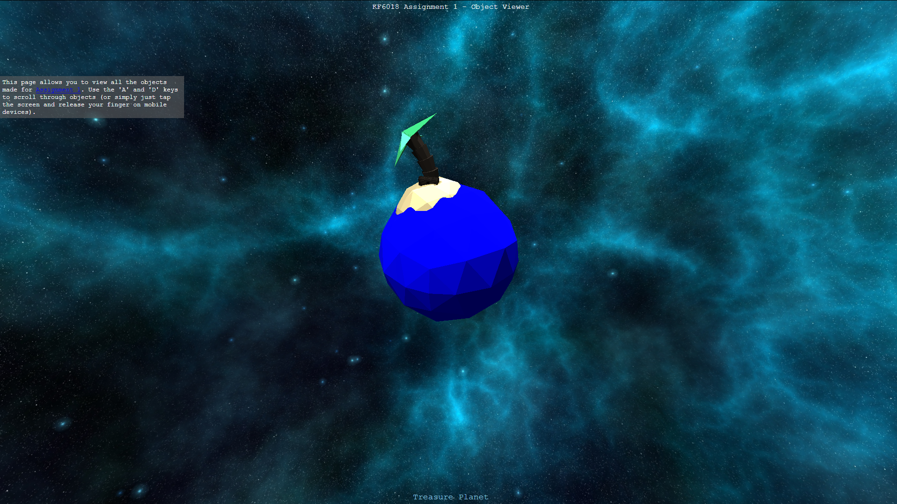

## GitHub

* We used GitHub to develop our project. A link to the repository has been placed here if needed.
* <https://github.com/andrewalford1/KF6018_Assignment_1.git>

# 3D Models: 20%

|  |  |
| --- | --- |
| **Implemented By:** | |
| **Andrew Alford (w16006135)** | **Ana-Sabina Irimia (w16001781)** |
| Dying Planet | Asteroid B612 |
| Moon | City Planet |
| Spaceship | Nature Planet |
| Treasure Planet | Sun |

# User Interaction: 20%

All user interaction was developed by Andrew.

## Main Project

The application can be controlled using the THREE JS Device Orientation Controls library. This allows the user to look around the scene from a first-person perspective.

## Object Viewer

Objects can be cycled using the “d” key to cycle forwards and the “a” key to cycle backwards. On mobile devices the user can tap the screen to cycle forwards.

# Graphical Rendering: 20%

## Art Style

There is a trade-off between visual quality and graphical rendering as all 3D Models created are modelled in a low-poly art style using a physical material with flat shading. This allows for an aesthetically pleasing art style with high performance rendering.

## Lighting

The project uses three point lights, one of them being the sun, and one ambient light to light-up the scene. Shadows are used throughout the project. Models can cast them and receive them to allow for lighting and shading effects.

## Materials & Textures

As previously mentioned, models use physical materials. This allows the materials to change the texture. For example, the water on the surface of the Nature Planet differs from the rest of the materials, having a shinier texture (this was possible by increasing the materials reflection).

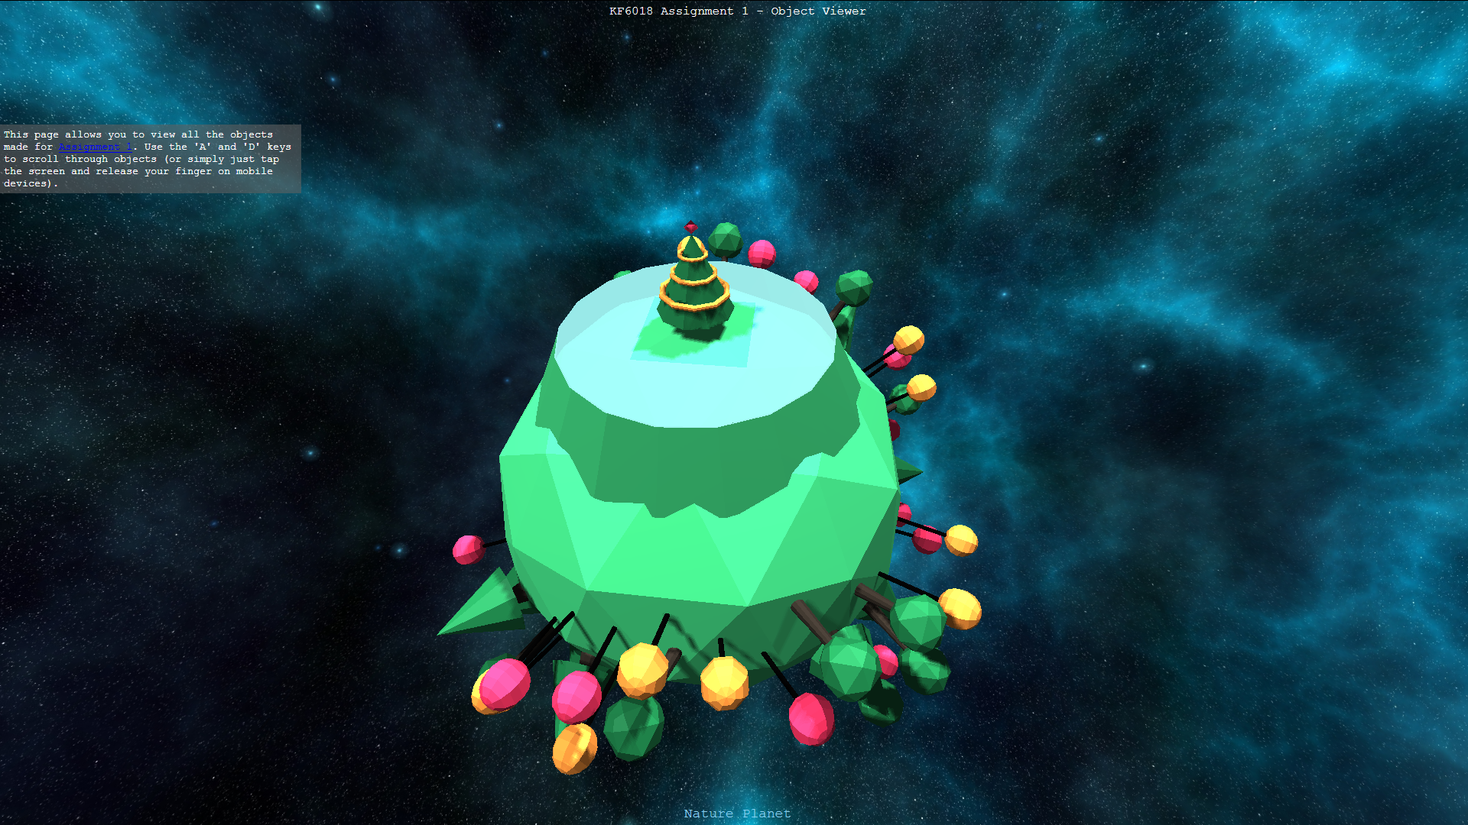

Textures have also been used in the project. These include the six textures loaded in for the scene’s skybox, as well as the texture modelled in Blender (3D modelling software) for the spaceship.

# Special Effects: 20%

The project includes several special effects such as the physics used to allow objects orbit around other objects. Because the engine the project runs on works with frame time (the amount of time in milliseconds it takes to compute and render one frame of animation), orbiting planets have realistic day/night cycles where the length of each day can be set as well as how long it will take each object to perform a full orbit.

Another special effect derives from the particle system implemented. An explosion particle effect has been implemented for the dying planet where one of its volcanoes will erupt every few seconds. Because of the Object-Oriented system implemented, it will be easy to create new customisable particle effects in future projects.

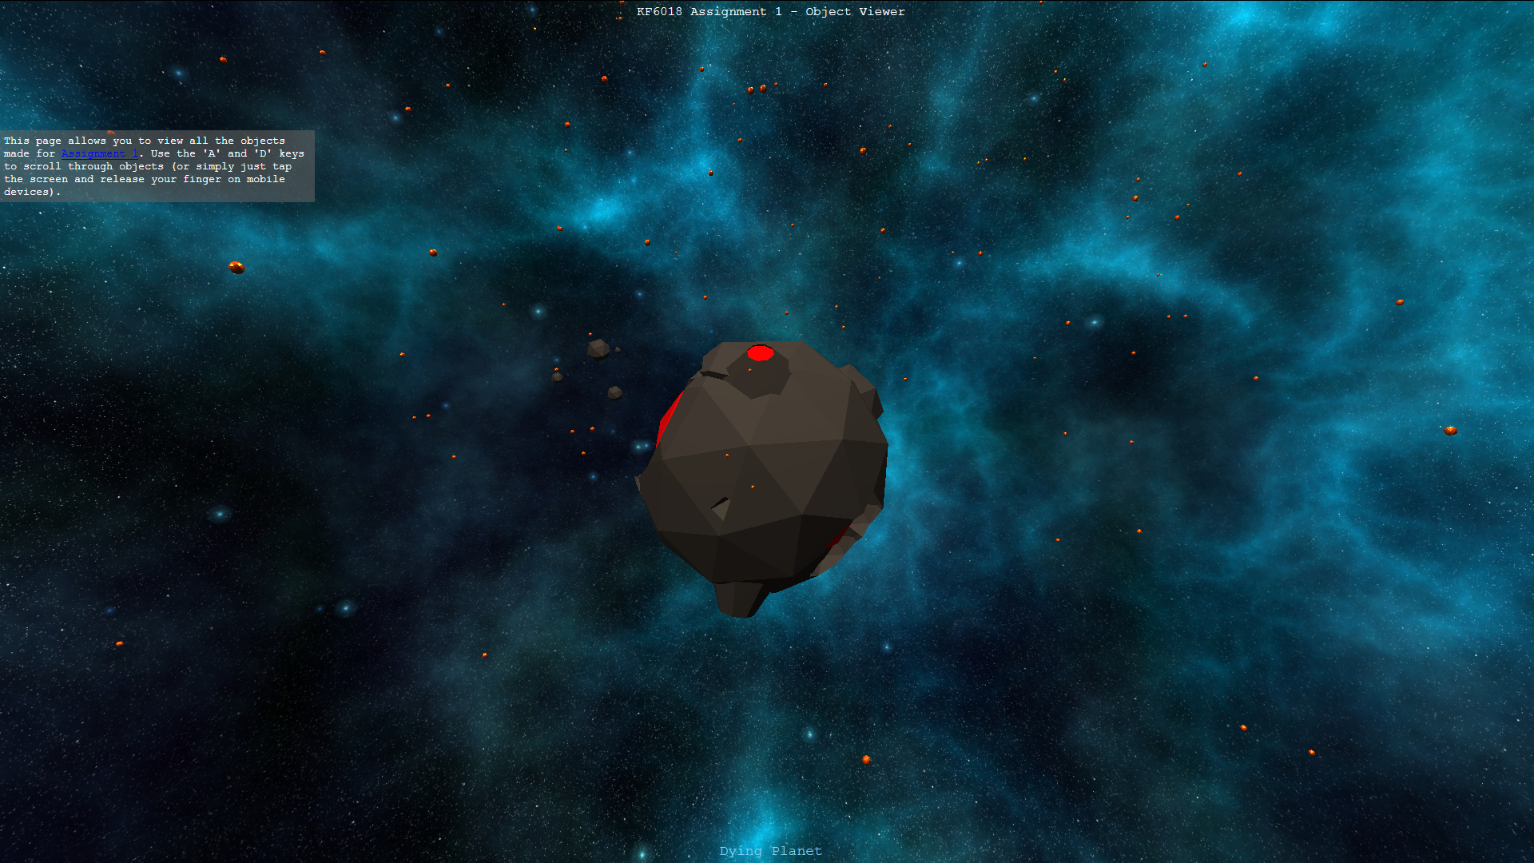

On the moon a special effect has been included where the flag will deform in the wind. This is created by using a wave effect on the vertices of the material.

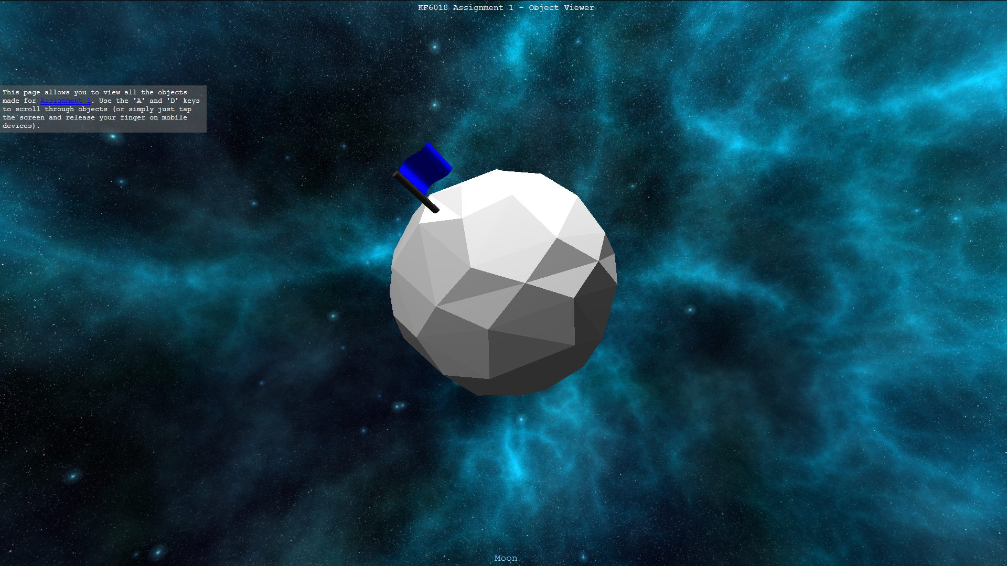

The last special effect implemented is the shield surrounding the city planet. Its opacity is cycled, creating a blinking effect.

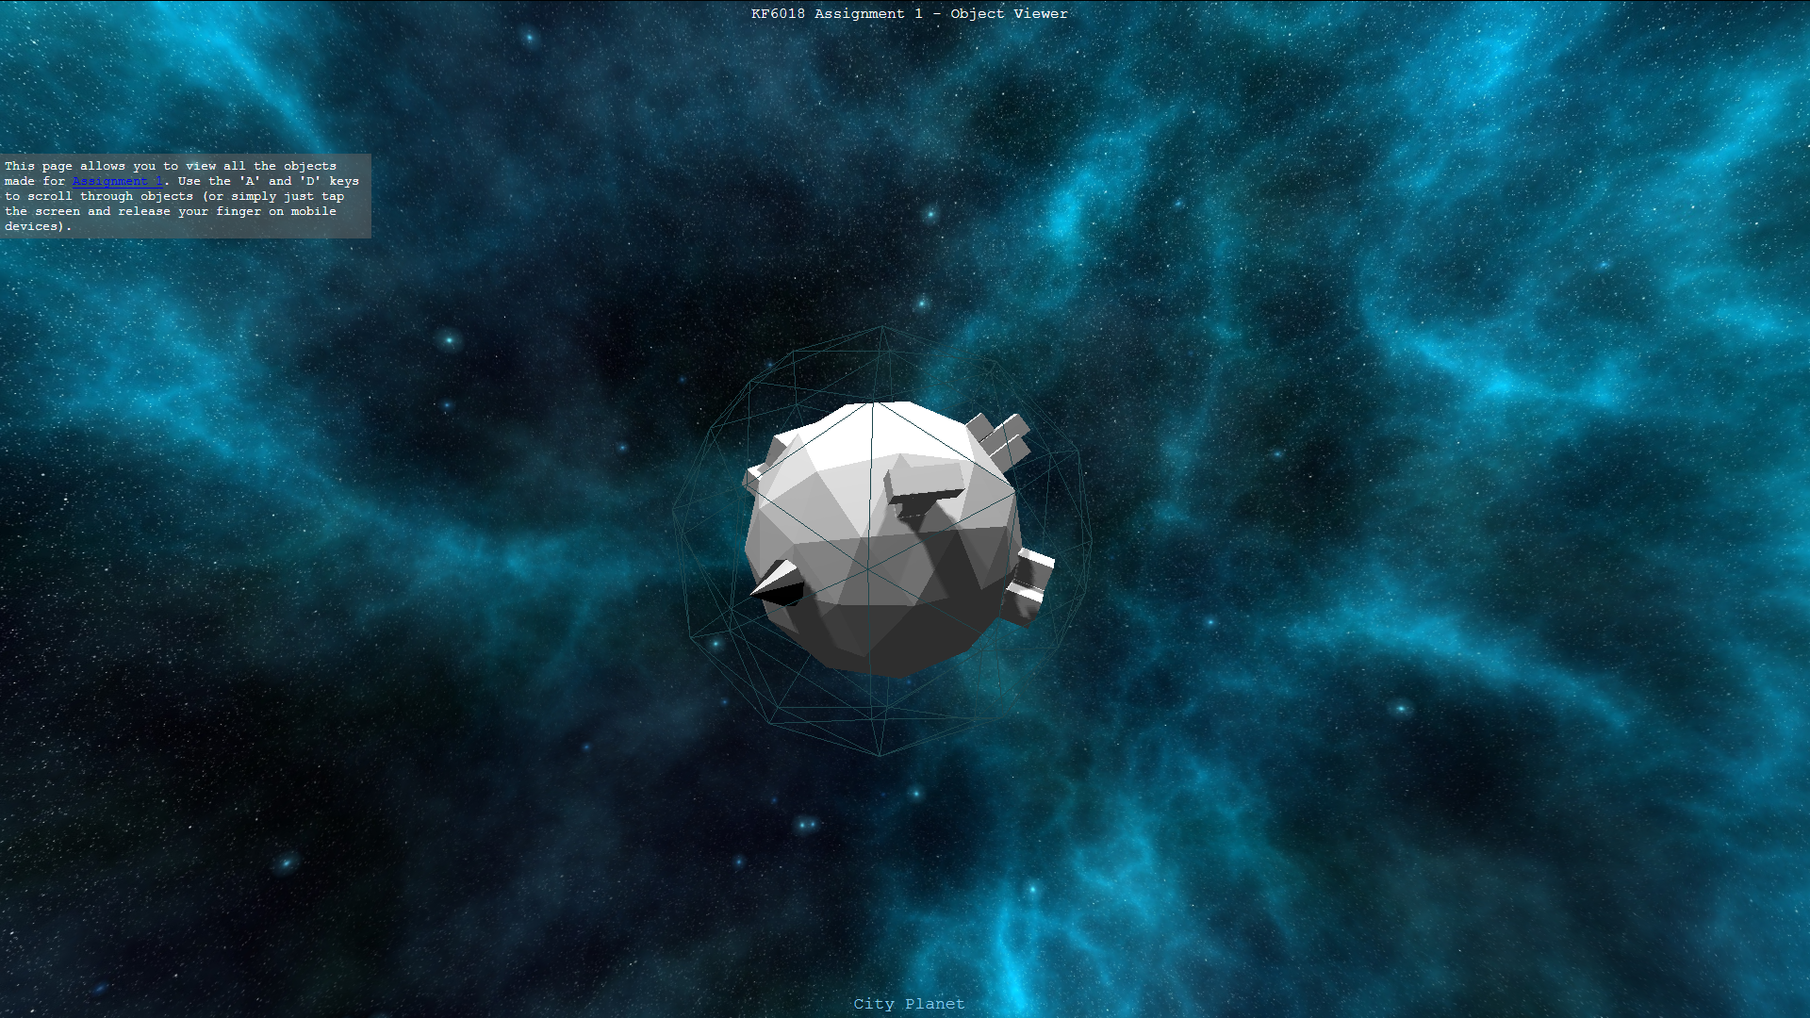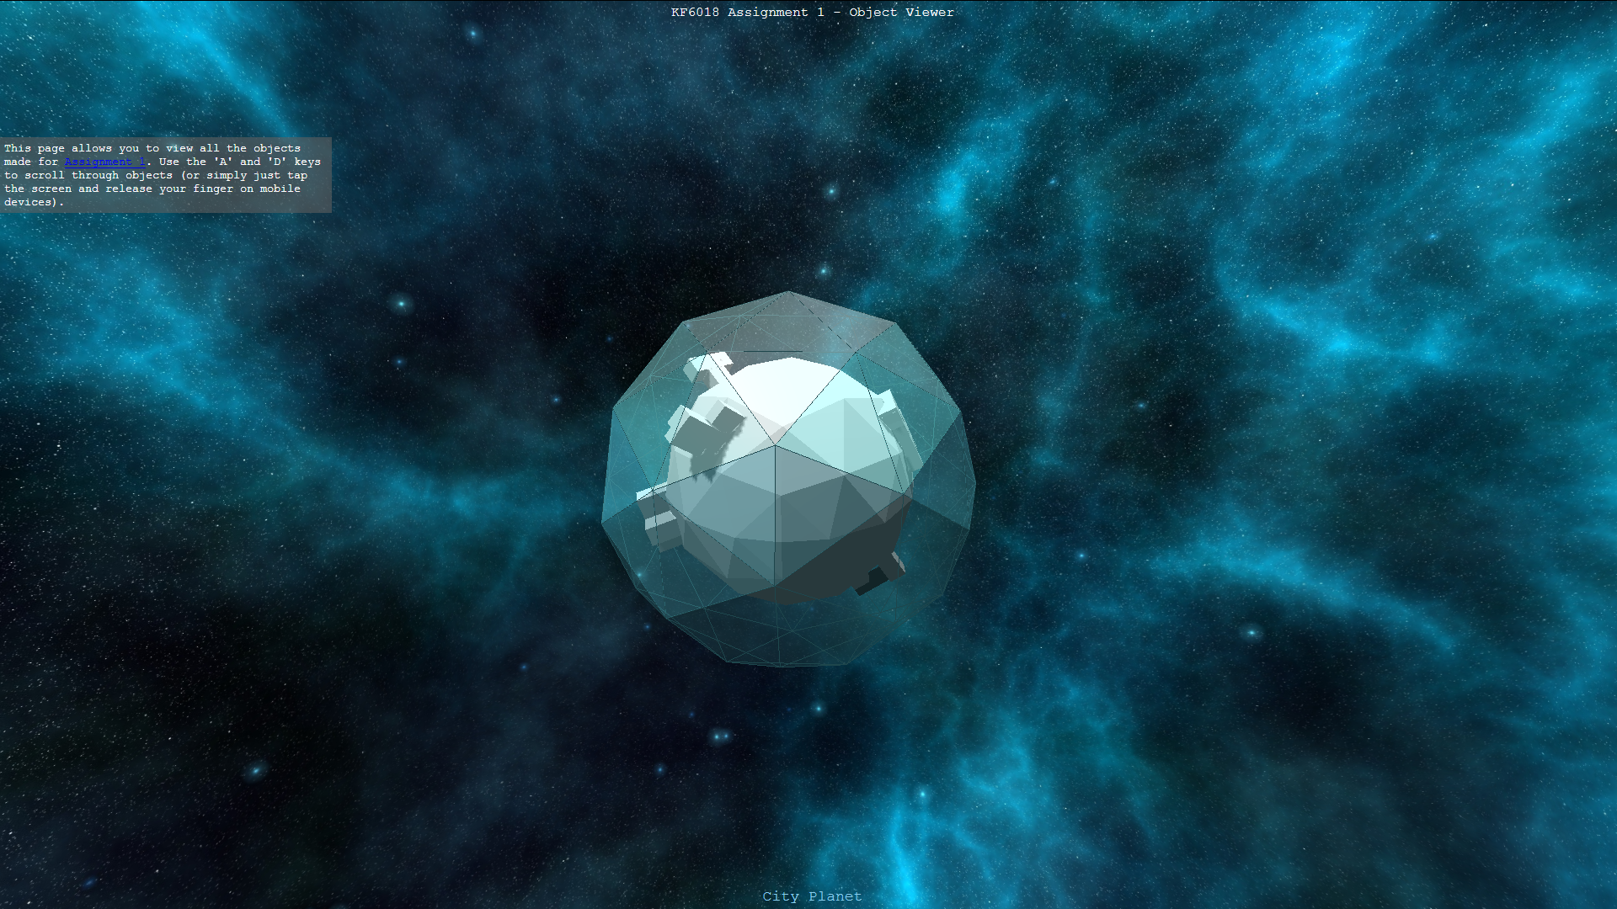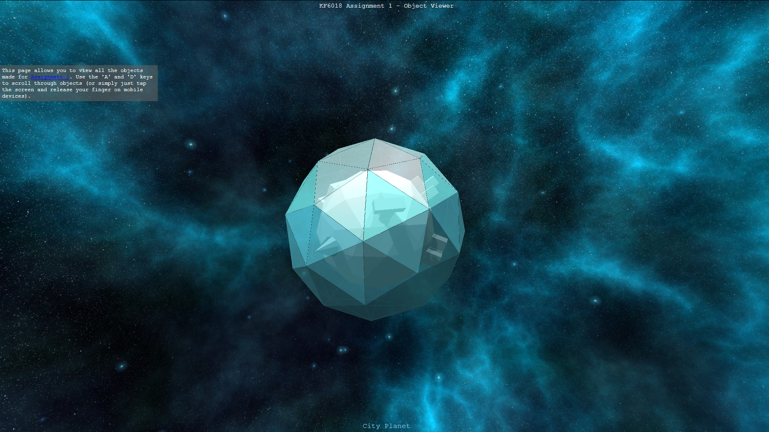

# Proposed Features – Andrew Alford (w16006135): 20%

JavaScript Object-Oriented programming has been used to abstract the assignment into “engine code” and “object code”. This allows for reusable and easy to use code. For example, the programmer does not need to worry about animating and rendering their objects, if the object has an update() function, then the engine code will do the animating and rendering for them. Taking inspiration from game engines, the engine has been designed to be as reusable and abstract as possible. The intent is to reuse and build upon this code for future projects.

Reusable code from the engine include:

* Customisable colour pallet.
* Model and texture loading.
* Object manager (stores and manages all the objects in the animation).
* Particle effect system.
* Keyboard input for user interaction.
* HTML accessor to allow html tags to be manipulated through JavaScript (this is how we can display the object names in object viewer.
* Reusable camera which also handles rendering. Controls and VR can be toggled.

Andrew also implemented all the physics and mathematics of the project to enable objects to orbit around each other using the concept of “frame time” and the in-browser clock.

Finally, Andrew created the object viewer. This is a separate HTML document which allows for each object to be cycled though and viewed individually. This application can be used to get a close-up detailed view of each object in the program.

# Proposed Features – Ana-Sabina Irimia (w16001781): 20%

Ana-Sabina has implemented the loading screen which runs whilst the main block of code is loading. It displays an animation of a changing planet Earth.

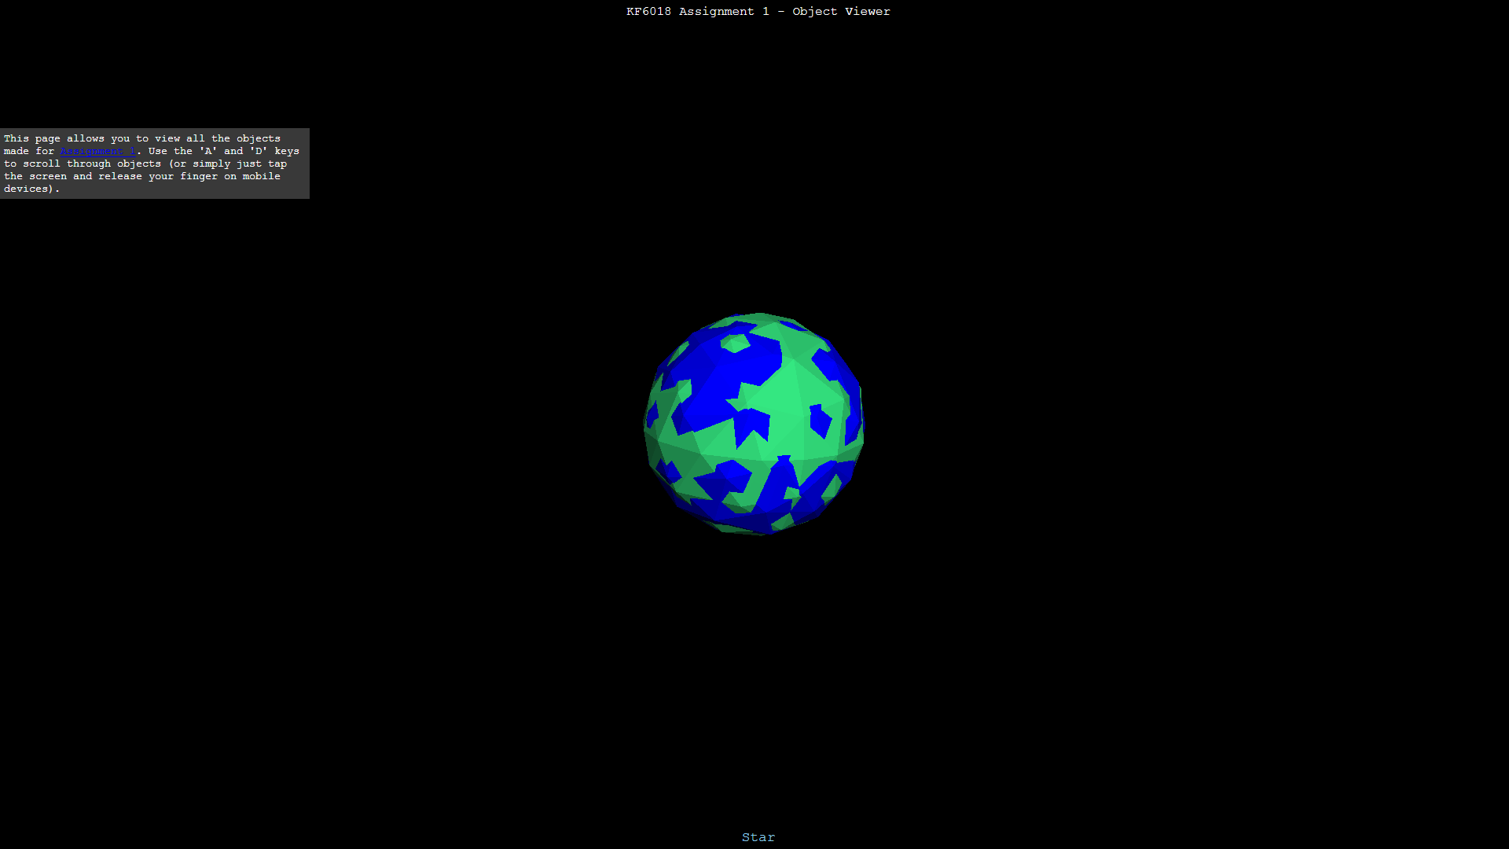

As well as this, Ana-Sabina also managed the style of the project. The low-poly art style was her idea, such as the style of the 3D models which use rough shapes and edges.

# References

* planetmoonstars. (2015). *Purple Saturn*. Retrieved from favicon.cc: <https://www.favicon.cc/?action=icon&file_id=843526>
* StumpyStrust. (2014, January 07). *Space Skyboxes*. Retrieved from opengameart.org: <https://opengameart.org/content/space-skyboxes-0>
* Several THREE JS libraries provided from in-class workshops have also been used. They can all be found within the ‘lib’ folder of the project.
  + DeviceOrientationControls.js – For control on mobile devices.
  + MTLLoader.js – For loading textures and materials.
  + OBJLoader.js – For loading 3D models.
  + OrbitControls.js – For flying around the scene.
  + StereoEffect.js – For VR rendering.